Mission 1 — Regeneration of Bone, Cartilage and Wound Regeneration

- What snail’s mucous consists of and potential biomedical relevance of those components
Component / Compound | Main Function | Potential Biomedical Relevance
Glycosaminoglycans (GAGs) | Water retention; interaction with extracellular matrix | Wound healing; tissue regeneration
Mucins | Viscosity; hydration; tissue adhesion | Wound protection; biomaterial development
Glycoproteins | Cell–matrix interactions; adhesion | Tissue regeneration; wound healing
Antimicrobial peptides / proteins | Antibacterial and antimicrobial activity | Infection control; wound care
Polysaccharides | Structural and gel-forming properties | Biomaterial and hydrogel development
Lectins | Carbohydrate-binding; molecular recognition | Potential cell-interaction and biomaterial applications
Allantoin | Skin-soothing and repair-associated activity | Dermatological and wound-care applications
Glycolic acid | Influences epidermal renewal and exfoliation | Skin regeneration and dermatological applications
Proteins and enzymes | Biological and enzymatic activity | Tissue repair and biomaterial development
Amino acids | Building blocks for proteins and biological processes | Cellular metabolism and tissue repair
Minerals / electrolytes | Contribute to physicochemical properties of mucus | Support of biological and material properties

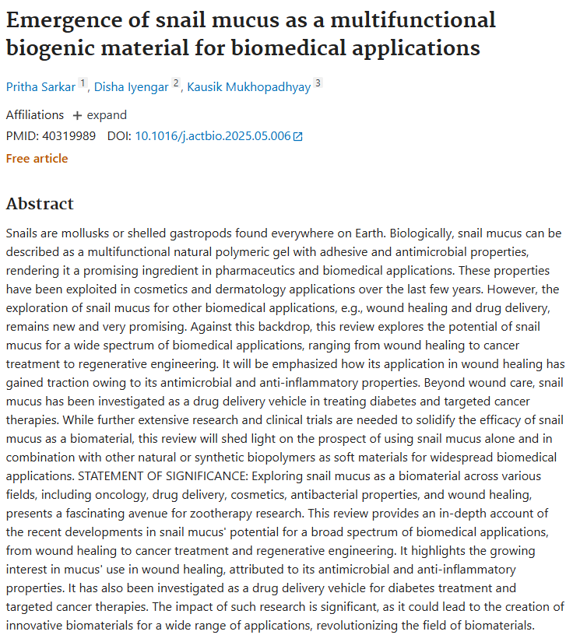
Overall: Snail mucus is a polymeric gel that has adhesive and antimicrobial properties. Due to these properties, snail mucus is considered a potential agent for use in a wide range of applications, from wound healing and the treatment of oncological diseases to regenerative engineering (restoration of bone and cartilage tissue). Special attention is paid to the use of mucus for wound healing, as it has antimicrobial and anti‑inflammatory properties. Furthermore, mucus is being studied as a means of delivering medicinal drugs for the treatment of diabetes and for targeted antitumor therapy.

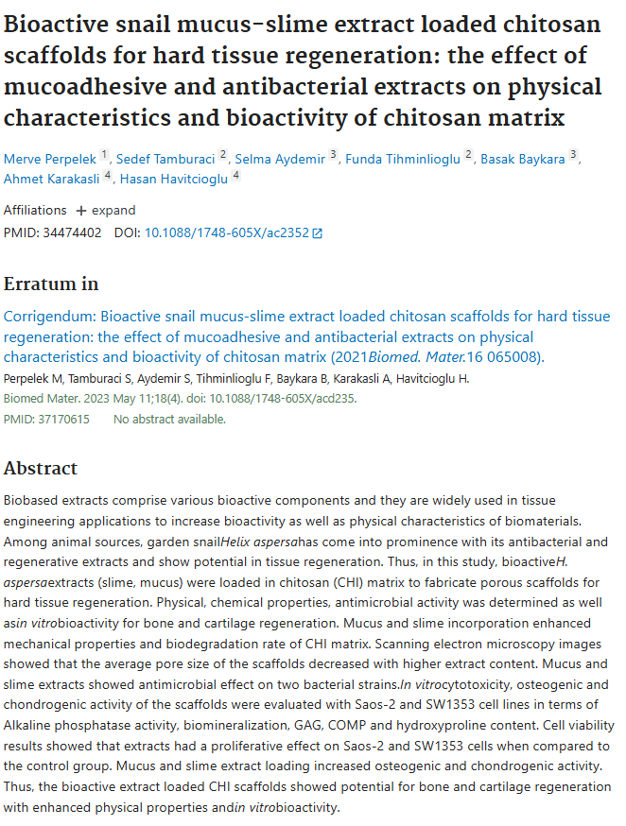
Overall: The garden snail Helix aspersa has attracted particular attention, as its extracts possess antibacterial and regenerative properties and demonstrate potential for tissue regeneration. In this study, bioactive extracts of H. aspersa (mucilage and mucus) were incorporated into a chitosan (CHI) matrix to create porous scaffolds designed for the regeneration of hard tissues. The addition of mucus and slime increased the mechanical properties of the chitosan matrix and the rate of its biodegradation. Images obtained using scanning electron microscopy showed that the average pore size of the scaffolds decreased with an increase in the extract content. Mucus and slime extracts demonstrated antimicrobial activity against two bacterial strains. Thus, chitosan scaffolds containing bioactive extracts have demonstrated potential for the regeneration of bone and cartilage tissues, while also exhibiting improved physical properties and biological activity in vitro.

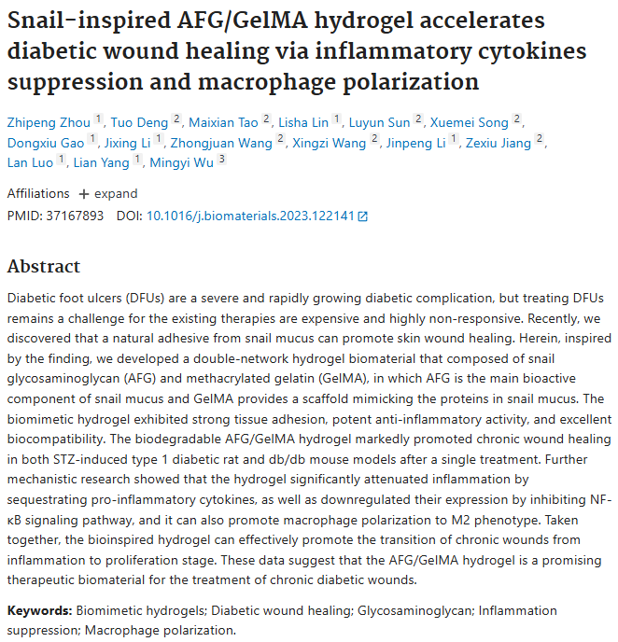
Overall: Researchers have developed a dual‑mesh hydrogel biomaterial consisting of snail glycosaminoglycan (AFG) and methacrylate‑modified gelatin (GelMA). The biodegradable hydrogel AFG/GelMA significantly accelerated the healing of chronic wounds in both rats with streptozotocin‑induced type 1 diabetes and in db/db mice after a single application. Thus, the hydrogel, created based on the principle of biomimicry, is capable of effectively promoting the transition of chronic wounds from the inflammatory stage to the proliferative stage, which is necessary for further tissue regeneration.The data obtained show that the AFG/GelMA hydrogel is a promising biomaterial for the treatment of chronic diabetic wounds.

- What problem we are addressing to, and what we offer
The Problem
Spaceflight places the human body in an environment that is fundamentally different from Earth. In microgravity, the mechanical loading of the skeleton is greatly reduced. As a result, bone-forming activity decreases while bone resorption continues, causing a net loss of bone tissue. NASA reports that astronauts can lose approximately 1–1.5% of bone mineral density per month during long-duration missions, particularly in weight-bearing bones such as the hips and spine. This reduction in bone density and strength increases susceptibility to fractures and creates additional challenges for long-duration exploration missions.
Space missions can also involve injuries that must be managed far from advanced medical facilities on Earth. This makes the development of compact, biologically active materials for tissue protection and regeneration an important area of research for future exploration.
At the same time, chronic and difficult-to-heal wounds remain a major challenge in medicine. Researchers are therefore investigating biomaterials that can simultaneously provide adhesion, hydration, antimicrobial protection, inflammation control, and support for tissue regeneration. Snail mucus has attracted attention because it naturally combines several of these properties.
Proposed Solution
Proposed Solution
Our mission proposes sending a living garden snail (Cornu aspersum, formerly known as Helix aspersa) to approximately 24 km altitude to investigate how extreme stratospheric conditions affect its physiology, regenerative biological responses, and the properties of the mucus it naturally produces.
Snail mucus is a complex biological polymeric material with adhesive, antimicrobial and anti-inflammatory properties. It contains bioactive components such as glycosaminoglycans, mucins, glycoproteins, polysaccharides, antimicrobial proteins and other biologically active compounds. These properties have attracted significant interest in wound healing, tissue engineering and regenerative medicine.
Previous research has demonstrated that snail-derived materials can support processes relevant to tissue regeneration. Helix aspersa mucus and slime extracts incorporated into chitosan scaffolds increased osteogenic and chondrogenic activity in vitro, demonstrating potential for bone and cartilage regeneration. Other snail-mucus-derived hydrogels have accelerated chronic wound healing in experimental animal models by reducing inflammation and promoting the transition from the inflammatory stage to the proliferative stage of healing.
However, these biomedical properties have primarily been investigated under controlled Earth-based laboratory conditions. Our mission asks a different question:
How does exposure to stratospheric conditions affect a living snail and the biological properties of the mucus it produces?
The snail will be maintained inside a protected biological module within the payload, where essential environmental parameters will be monitored and controlled as far as technically possible. Environmental data recorded during flight will be compared with the snail's physiological condition and mucus characteristics after recovery.
Following the mission, the mucus will be analyzed and compared with a ground-control sample obtained from snails maintained under the same terrestrial conditions. The comparison will focus on measurable properties such as structural stability, adhesion, hydration, antimicrobial activity and other relevant biological characteristics.
The objective is not to assume that stratospheric exposure will improve the mucus. Instead, the mission will determine whether exposure causes measurable changes and whether important functional properties are preserved.
If the snail survives the flight and its mucus retains relevant biological activity, the results could provide a basis for further research into snail-derived regenerative biomaterials. Such materials could eventually be investigated for applications in wound care, tissue engineering, and regenerative medicine, including biomaterials designed to support soft-tissue, cartilage and bone repair.
In this way, the mission connects space biology, regenerative medicine and biomaterials science by using a living organism to investigate whether a naturally produced regenerative material can remain biologically functional after exposure to the extreme environment of the stratosphere.
Why Is This Relevant to Space Exploration?
The same biological challenge that makes tissue regeneration important on Earth becomes even more significant during long-duration spaceflight. Microgravity causes measurable changes in bone remodeling and increases the risk associated with weakened skeletal tissue. NASA is already studying biological and pharmacological countermeasures aimed at protecting astronaut bone health.
Our concept approaches the problem from a different direction: rather than attempting to prevent every injury, we investigate a bio-derived material platform that could potentially support tissue repair.
Thus, the mission connects two fields:
Space medicine → need for effective biological countermeasures
Regenerative biomaterials → snail mucus as a multifunctional natural material
The successful preservation of these properties after stratospheric exposure would be an important first step toward determining whether snail-mucus-derived materials deserve further investigation for future biomedical applications in space.

